Ideation Phase

Define the Problem Statements

|  |  |
| --- | --- |
| Date | 19 September 2022 |
| Team ID | PNT2022TMID24448 |
| Project Name | Project – Real-Time River Water Quality Monitoring and Control System |
| Maximum Marks | 2 Marks |

**Customer Problem Statement Template:**

Create a problem statement to understand your customer's point of view. The Customer Problem Statement template helps you focus on what matters to create experiences people will love.

A well-articulated customer problem statement allows you and your team to find the ideal solution for the challenges your customers face. Throughout the process, you’ll also be able to empathize with your customers, which helps you better understand how they perceive your product or service.

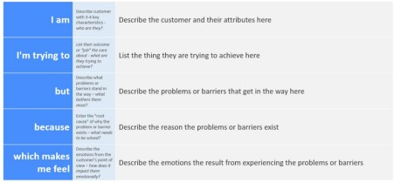

Reference: https://miro.com/templates/customer-problem-statement/ **Example:**



|  |  |  |  |  |  |
| --- | --- | --- | --- | --- | --- |
| **Problem**  **Statement (PS)** | **I am**  **(Customer)** | **I’m trying to** | **But** | **Because** | **Which makes me feel** |
| PS-1 | A farmer | Check the water  quality. | Procedu re to  find the quality will be more  and take more time. | Generally specific researche rs only handle  this. | Helpless most of the time. |
| PS-2 | A drinking water supplier | Check the level of chlorine in water. | I need to depend on any  third party water  researcher. | My lack of knowledge on water  quality. | More dependence and expenditure on water search. |
| PS-3 | Industrialis | Check type | I need to depend on any  third party water  researcher. | Generally | That it is an |
|  | t | of water | specific | additional expense |
|  |  |  | researche |  |
|  |  |  | rs only |  |
|  |  |  | handle |  |
|  |  |  | this. |  |
| PS-4 | Fishermen | Find if the water is suitable for aquaculture | It is  difficult to obtain the results | My lack of knowledge on water  quality. | That it is costly |